BERKELEY COMMUNITY MENTAL HEALTH CENTER
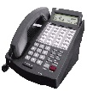
PHONE/VOICE MAIL INSTRUCTIONS
This Photo by Unknown Author is licensed under CC BY-ND

PHONE INSTRUCTIONS AND FEATURES

PLACING CALLS
INTERNAL CALLS OUTSIDE CALLS
- Lift handset (optional) Lift handset (optional)
- Press “ICM” button (or pre-programmed button) Press “IN/OUT”
- Dial extension number (ext. # +1; Example: 3001) Dial telephone number

ANSWERING CALLS
INTERNAL CALLS OUTSIDE CALLS
- Press “HF” or lift handset Press “IN/OUT” key

VOLUME CONTROL
- RINGER VOLUME – while phone is ringing, adjust volume keys up or down
- SPEAKER VOLUME – while speaker is in use, adjust volume keys up or down
- HANDSET VOLUME – while handset is in use, adjust volume keys up or down

DISPLAY CONTRAST
Press volume keys up or down while phone is not in use or ringing in order to adjust the display.

MUTE
When this key is lit solid red, the MUTE is activated and this prevents the caller from hearing you. Simply press the “MUTE” key to deactivate.

DND – DO NOT DISTURB

If the DND button is pressed, all calls will automatically go directly to voice mail. This feature allows you the privilege of not being disturbed during sessions. Only 3 beeps will be heard indicating that a voice mail message has been placed in your voice mailbox and the indicator light at the top right of the phone will flash. If this key is activated, NO PHONE CALLS WILL COME THROUGH TO INCLUDE EMERGENCY CODES. (This is why codes are sent through the overhead speaker system in addition to the phone).

STORING ONE TOUCH EXTENSION KEYS (for frequently dialed extensions)
- Press “SPD/LNR” key
- Press key to be programmed
- Press “ICM”
- Dial 3-digit extension number to be stored
- Press “SPD/LNR” key TWICE
- Press “HF”
- When calling an extension using this feature, press the number 1 afterwards so force the call to “ring”
STORING ONE TOUCH KEY FOR FREQUENTLY OUT-DIALED NUMBERS
- Press “SPD/LNR” key
- Press key to be programmed
- Dial the telephone number to be stored (up to 16 digits)
- Press “SPD/LNR” key TWICE
- Press “HF”
  - TO USE THE ABOVE STORED AUTODIALS
    - Press “IN/OUT”
    - Press the programmed key

TRANSFERRING CALLS
WITH A CALL IN PROGRESS
- Press “TRF” button
- Dial 3-digit ext. number or press pre-programmed button
- Announce the call (if desired)
- Hang up to release call
- Press “TRF” to return to caller

PARKING CALLS (Placing an outside caller on “HOLD”)
WITH AN OUTSIDE CALLER ON THE LINE
- Press “PARK”
- To answer/return to parked call from the same phone, press “PARK”
- To answer a parked call from a different phone, press “PARK” and dial 3-digit ext. where the call was parked

HOLD (Place inside calls on “HOLD”)
WITH AN INTERNAL CALLER ON THE LINE
- Press “HOLD” and press “HOLD” to return to caller

LAST NUMBER REDIAL (SPD/LNR)
- Lift handset (optional)
- Press “IN/OUT”
- Press “SPD/LNR” button twice

TRUNK QUE (Use when all out-dial lines are busy)
If “IN/OUT” is solid red, this indicates that all out-dial lines are busy
- Press “IN/OUT”
- Dial #1 – When an out-dial line becomes available, the phone will ring and you can dial desired number upon pressing “IN/OUT.”
- To cancel Trunk Que, press “ICM” button and dial #1

PAGING
INTERNAL THROUGH PHONES or EXTERNAL (SPEAKERS)
- Press “EXTENSION PAGE” Press “OVERHEAD PAGE”

CALL FORWARD > Press ICM
Press #
Dial 920
Dial the number to which you want your calls forwarded
Press HF
CANCEL CALL FORWARD > Press ICM
Press #
Dial 900

SELECTING A RING TONE
- Without lifting the handset:
  - Press “ICM”
  - Dial *51, *52, *53, or *54
CONFERENCE CALLS

***CAN NOT USE “HF” WHILE ESTABLISHING THE CALLS. “HF” can be used once all calls have been established.***

- FOR ONE OUTSIDE CALL AND TWO INTERNAL CALLS
With an outside call in progress
  - Press “TRF” (will automatically put the call on hold)
  - Dial the extension number to be joined into the call
  - Announce “Conference Call”
  - Press “CONF” key to join parties

- FOR TWO OUTSIDE CALLS AND ONE INTERNAL CALL
With an outside call in progress
  - Press “TRF” (will automatically put the call on hold)
  - Dial 9 for an available outside line
  - Dial telephone number of party to be joined into the conference call
  - Press “CONF” (NOTE: If you receive a busy signal or no answer, Press “TRF” to return to the first party
  - Repeat steps to add the 2nd outside caller

NOTE: A MAXIMUM OF 3 PARTIES MAY BE JOINED IN A CONFERENCE.

TELEPHONE DURESS SYSTEM:

As stated in Policy S040, Section II, “All telephones are programmed with a panic/duress button, overhead paging button and handset paging button used in situations of aggression and/or violence in the workplace.”

The details of the Violent Situations policy and procedures are posted under “Center Policies and Procedures” located on our Staff Resource Page within the “Publications” section.

The purpose of this page is to serve as a reminder/recap of functionality of the duress system on all telephone handsets and how they are used in the event of a violent or potentially violent situation.

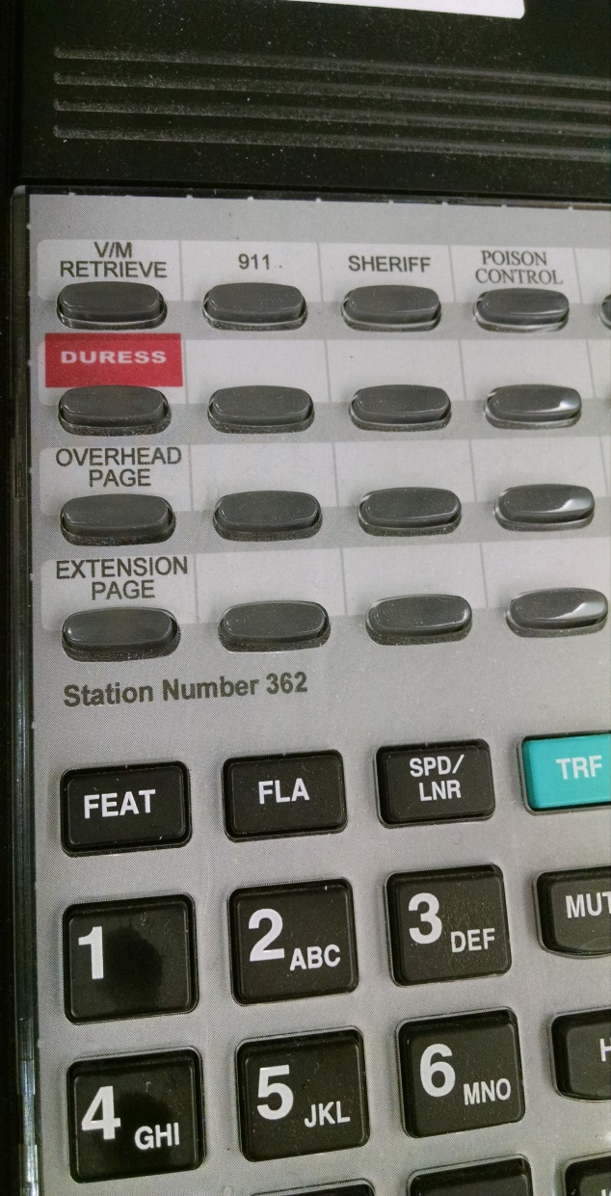
If you press the red DURESS button, the reception area will hear your conversation but you and the client will not hear any conversation coming from the reception area. You can continue your interview using the appropriate code words for your given situation (i.e. Armstrong, Dangerfield, Sharp or Winchester).
If you need to page all telephone handsets in the building, press the EXTENSION PAGE button.
If you need to use the overhead speakers for some situation, you would press the OVERHEAD PAGE button plus “0”. This will allow you to broadcast information over the loudspeakers which are located throughout the facility.

VOICEMAIL INSTRUCTIONS AND FEATURES

SAMPLE VOICE MAIL GREETING (This is the number 1 greeting).

You have reached the office of ____________. I’m not available to answer your call at this time. Please leave your name, phone number, and a brief message and I will return your call as soon as possible. If you need immediate assistance, please press zero before the tone to speak to the operator.

VOICE MAIL SET-UP
Press the V/M RETRIEVE button (1st button top left)
Press 9 – USER MENU
Press 7 – QUICK SET-UP
Press 1 – QUICK SET-UP > Follow Prompts

PROGRAMMING 1 TOUCH BUTTON FOR VOICE MAIL ACCESS

***WITHOUT LIFTING THE HANDSET***
- Press SPD/LNR button
- Press the top left button labeled VM RETRIEVE
- Dial 332
- Dial personal extension number
- Press “1”
- Press the SPD/LNR button TWICE
- Press HF button
NOTE: Once programmed, simply press this one button to retrieve messages.

ACCESSING VOICE MAIL FROM OFF-SITE

- Dial 843-899-0006
- Dial 999 – AFTER the auto attendant starts.
- Dial your personal extension number.
- After the prompt, dial your password (which is supposed to be the same as your ext. number)
- Press “1” for Message Management.

DELETE VOICE MAIL MESSAGES REGULARLY

If messages are not deleted in a timely manner, the voice mail system will not work properly causing a delay in receiving messages and eventually will not be able to receive any messages.

FORWARDING VOICE MAIL MESSAGES
After listening to a message
- Choose Option 5
- Press 7 to forward message to an extension number
- Press 2 to record message prefix (description of message before forwarding to another person)
- Press 3 to review message prefix
- Complete forwarding the message by following the prompts
TO ADD AN ADDITIONAL PERSONAL GREETING

NOTE: TO BE USED WHEN OUT OF THE OFFICE FOR AN EXTENDED PERIOD OF TIME; EX: VACATION,
SICK LEAVE, ETC.

- Press VM RETRIEVE button
- Press 2 (for Call Management)
- Press 4 (Follow instructions. DO NOT use “0” or “1” because “0” is the system answering service and “1” is your regular current personal greeting. Use “2” through “9” and then record your message).
EXAMPLE: You’ve reached the office of _____. I will be out of the office until _______. If you need immediate assistance, please press “0” to speak to the operator and ask to be transferred to __________.
- You are now able to select the greeting number that you wish to have heard by the caller. DO NOT FORGET to change the greeting back to the #1 greeting when the other greeting is no longer valid.

INTERCEPTING VOICE MAIL GREETING

If an extension is dialed and the call goes to the voice mail greeting, simply press the “#” key to interrupt the greeting and go straight into voicemail so that you can leave a message without waiting to hear the entire greeting.

CLEARING VOICE MAIL FLASHING LIGHT

Steps to clear the voice mail flashing light when there is actually no voice mail.

WITHOUT LIFTING THE HANDSET, press the following keys in this order:

FEAT
MUTE
FLA
HF
MUTE
HF (may have to press this button twice)

